PathClear: Technical Architecture & Implementation Blueprint
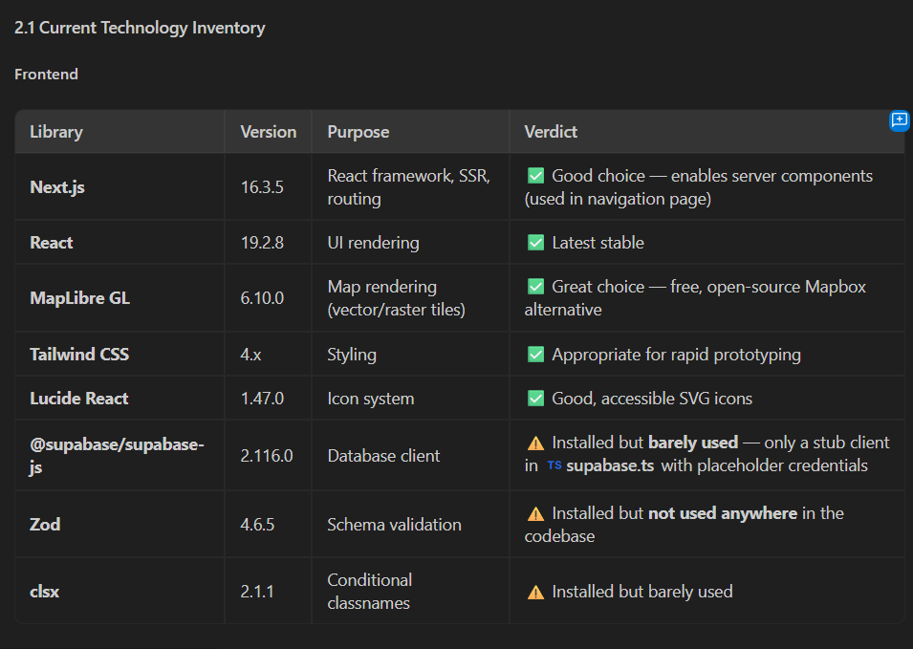
- System Diagnosis: What is Currently Broken
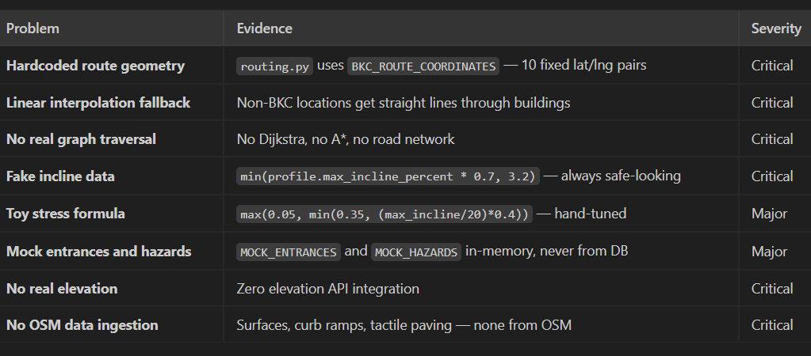
CURRENT ARCHITECTURE (Disconnected Simulation): Frontend (Next.js) ──> Hardcoded SVG Bezier curve (No real geometry)
Backend (FastAPI) ──> routing.py: Hardcoded 10 BKC coordinates / Straight-line interpolation
Database (PostGIS) ──> Disconnected: Complete schema exists in db.sql, but is never queried

.1 Backend Vulnerabilities (routing.py)
- Hardcoded Coordinates: The backend returns a static array of 10 coordinates (BKC_ROUTE_COORDINATES). If a user searches for any destination outside this hardcoded corridor, the app falls back to drawing a straight line directly through buildings and obstacles.
- Zero Graph Traversal: There is no pathfinding algorithm (Dijkstra or A*) executing against a street network.
- Cosmetic Accessibility Math: Accessibility filters are simulated using arbitrary formulas. The route's incline is generated using min(profile.max_incline_percent * 0.7, 3.2) to ensure routes always appear safe, while require_step_free and avoid_broken_surfaces flags are completely ignored during path calculation.
- Toy Stress Metric: The route difficulty is computed using a hand-tuned formula: max(0.05, min(0.35, (max_incline / 20) * 0.4)). This formula lacks physical meaning and ignores segment-by-segment road conditions.
- Disconnected Data: All building entrances and hazards are served from in-memory mock lists (MOCK_ENTRANCES, MOCK_HAZARDS) instead of the spatial database.
1.2 Frontend Limitations (Map.tsx)
- Decorative SVG Canvas: The map renders an SVG spline curve rather than a true GeoJSON route layer pinned to geographic coordinates.
- Flat Raster Tiles: The UI loads basic OpenStreetMap 2D raster image tiles without 3D building extrusions, vector layers, or dynamic pitch angles.
- Missing Device APIs: Neither the Web Speech API (voice), the Geolocation API (watchPosition), nor the DeviceOrientation API (compass heading) are integrated into the active navigation loop.
2. Critical Idea Gaps & Strategic Fixes
Analyzing the initial concepts reveals several real-world operational bottlenecks. T
Table mei there are strategies is problem ke liye
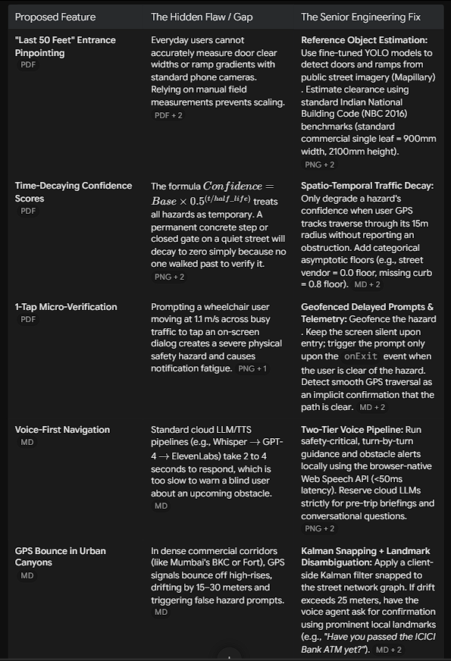

What is Kalman-
when a user is walking or using a wheelchair between tall buildings (like the structures around the Bharat Diamond Bourse in your screenshot), the GPS signal bounces off the glass and concrete. This causes the blue location dot on your MapLibre frontend to jump wildly across the screen or teleport to adjacent streets.
A Kalman filter solves this by continuously looping through two steps:
- Prediction: Based on the user's last known position, speed, and heading, where should they be right now?
- Measurement: Where does the raw, noisy GPS sensor say they are?
The filter calculates the statistical sweet spot between the logical prediction and the noisy measurement, plotting a smooth, continuous line instead of an erratic zigzag.

Main fix required – routing engine
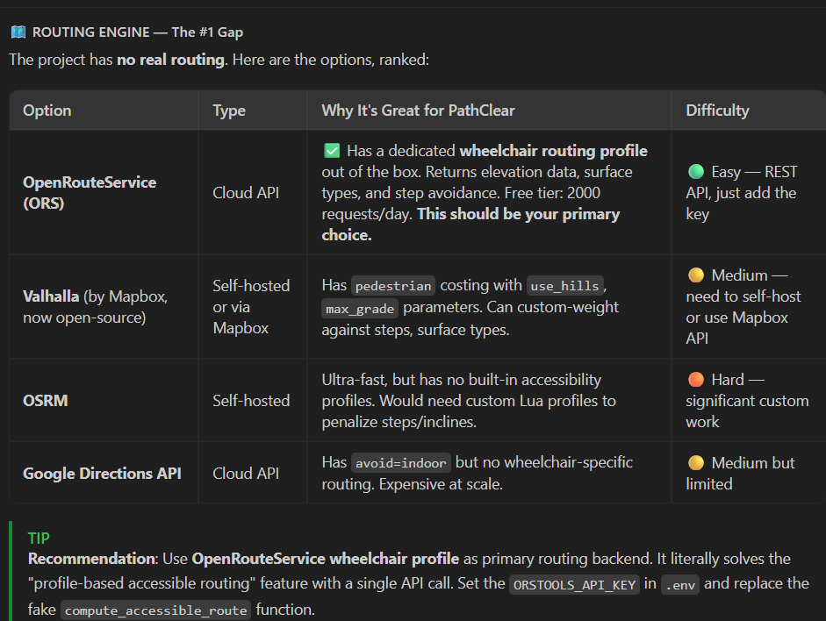
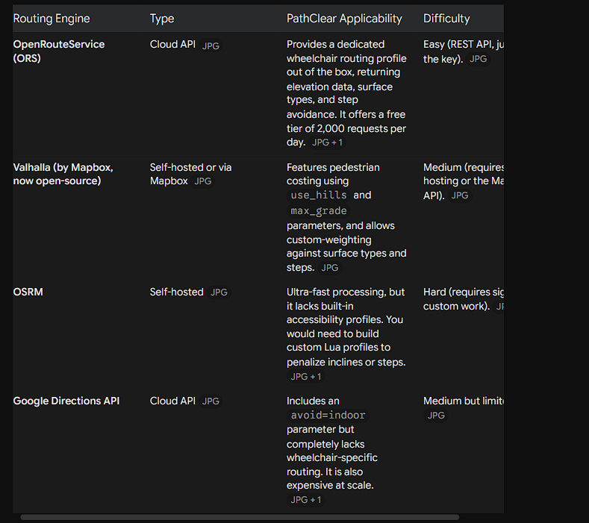
See more in different plans section below.
2. Analysis of Your Proposed Solutions
2.2 Time-Decaying Confidence Scores
- Asymptotic floor: Excellent. max(Floor, Base * 0.5^(t/half_life)) prevents decay to zero.
- 90-day+ half-life: Correct. Current 168h for entrances is absurd.
- Remove decay entirely: Overcorrection. Doors break, renovations happen. Better: 180-day half-life with floor=0.8 for structural, 7-day with floor=0.1 for operational.
- Lock verified after YOLO: Dangerous. YOLO has 3-5% false positives. Better: YOLO -> confidence=0.7, human -> 0.95.
Improved formula: Confidence = max(Floor[type], Base * 0.5^(t/half_life[type]) * (1 + log2(1+verifications_7d)/10))

2.3 Voice Agent for Blind Navigation
- Voice instead of tap: Essential for safety during navigation.
- GPS stall/detour detection: Smart. Only prompt on behavior change.
- 15m geofence: Good (~13s warning at wheelchair speed).
- Voice surveyor: Ambitious but feasible as voice-driven structured form.
- GPS bounce via landmarks: Clever. Requires OSM POI database.
Additional: Snap-to-road GPS correction first (Kalman filter + road projection). Only escalate to voice if >25m uncertainty

2.4 Profile-Based Routing with OSMnx
- OSMnx graph download: Perfect for prototype. Save as .graphml.
- NetworkX shortest_path: 200-400ms, doesn't scale. Pure Python.
- Penalty weighting: Correct (steps=infinity, cobblestone=5x).
Push toward Valhalla: C++ <50ms. Native custom costing. Auto-generates turn-by-turn instructions.

2.1 Entrance Data via YOLO + Mapillary/Street View
Mapillary: Excellent. Free, CC-BY-SA, blurs faces. Good BKC coverage.
- YOLO for detection: Feasible. YOLOv8/v11 for doors, ramps, stairs. ~2000 images to train.
- Width inference: Fragile. Monocular depth has 15-25% error. Better: use Mapillary depth maps or door frame as reference (Indian commercial: 2100mm x 900mm per NBC 2016).
- Bootstrap: Real issue. Batch-process Mapillary offline (~48h GPU for 50K images).
- Freshness decay: Sound. 6-month threshold reasonable for permanent infrastructure.
- Gamification: Risky for MVP. Better: partner with disability orgs (ADAPT Mumbai, Enable India).
Main flaw: A ramp detected by YOLO does not tell you its slope. Without stereo/LiDAR, measurements are approximations. Label as confidence: estimated and flag for verification.

2.6 Walking Guide Voice Agent
Enrichment must happen in FastAPI middleware: Valhalla maneuver -> FastAPI enrichment -> Enriched JSON -> Frontend voice
Queries: OSM Overpass (surface/tactile/crossing), Elevation API (slope), Hazard DB (30m radius), Entrance DB (Last 50 Feet).

. Additional Strategies
- Shadow Routing: Compare planned route vs actual GPS trace. Auto-flag deviation hotspots.
- Passive Signal Verification: Speed drop = surface issue, stop = barrier, orientation change = confusion. Zero friction.
- Weather Re-scoring: Rain -> unpaved 3x->6x. Ice -> slopes >2% get 10x. Heat -> uncovered 1.5x.
- Route Rehearsal: 3D fly-through at 10x speed. MapLibre flyTo() chained. 15-30s for 20-min route.
- Verbal Rerouting: "Route blocked. Alternative adds 4 min, 3% slope for 50m. Switch?"

3. Core Algorithmic & UX Models
3.1 The Route Friction Index (RFI)
Replace the arbitrary stress formula with a distance-weighted impedance model. A route is broken into n distinct segments, where each segment i has length d_i (d and chota i).
Ex- Segment 1: Flat Asphalt (d=100m, M=1.0) ──> Segment 2: 4% Slope Pavers (d=50m, M=2.2) ──> Destination

For each segment, calculate the Physical Effort Multiplier (M_i):
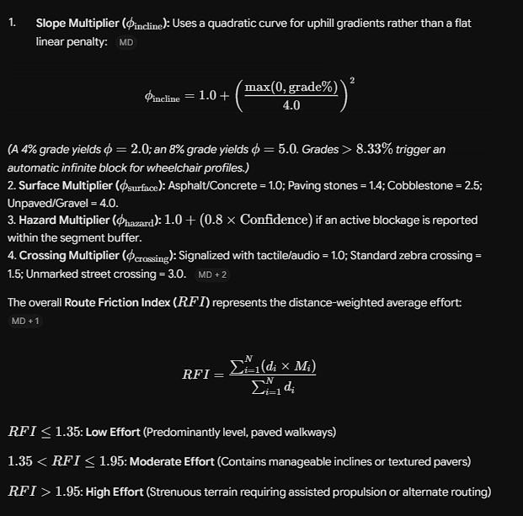

3.2 Actionable UX: The Nutrition Label & Go/No-Go Gatekeeper
Avoid presenting users with an abstract decimal score (e.g., "Stress: 0.18"), which offers little practical utility. Instead, implement two deterministic UI components

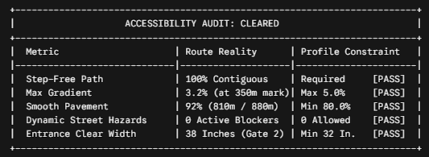The
Go/No-Go Gatekeeper: If any parameter is marked [FAIL] (e.g., three unmapped steps detected along the only accessible pathway), the application blocks the route and triggers a modal:
Route Inaccessible Under Your Profile: An unavoidable 3-step barrier was identified 400m along this path.
[Calculate Detour: +350m / Flat Pavement]

4. Multi-Modal Profile Engine: Step-by-Step Guidance(imp)
Because accessibility needs vary significantly across user groups, route calculations, UI layouts, and sensory outputs must dynamically adapt based on the selected user profile
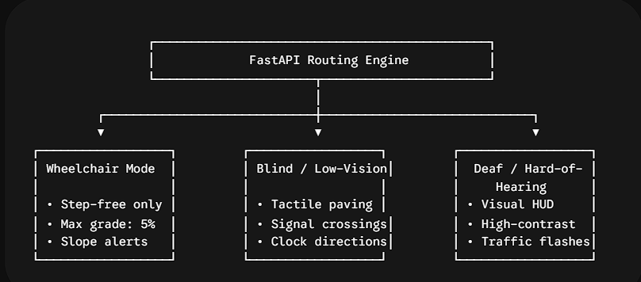also normal pedestrian mode for normal people.

4.1 Wheelchair & Motorized Scooter Guidance
- Impedance Focus: Prunes edges tagged with highway=steps or curbs where kerb > 0.03m. Penalizes slopes exceeding 5%.
- Audio/Visual Guidance: Delivers terrain foresight alerts 15 meters prior to transitions: "Approaching an uphill section: 3.5% incline for the next 40 meters."
- Arrival Handover: Within 15 meters of the destination, the UI transitions to the Last 50 Feet Entrance Card, displaying an exterior photo, ramp slope indicators, and door mechanics ("Arriving at Gate 3. Push-button automated door on your right").
4.2 Blind & Visually Impaired Guidance
- Impedance Focus: Permits stairways if accompanied by handrails (handrail=yes). Penalizes wide, open plazas lacking continuous physical boundaries (highway=pedestrian without tactile pavers), as these present spatial orientation challenges. Prioritizes edges with tactile_paving=yes and crossings featuring crossing:signals=audible.
- Clock-Face Spatial Guidance: Translates bearing changes into clock-face directions relative to device heading: "At your 2 o'clock, follow the ribbed tactile paving for 25 paces".
- Hazard Proximity Haptics: Fires distinct vibration cadences 20 meters before hazards: three short vibration pulses for temporary physical obstructions, and a single prolonged pulse for signalized street crossings.
4.3 Deaf & Hard-of-Hearing Guidance
- Impedance Focus: Penalizes shared streets (highway=living_street), narrow pedestrian paths bordered by blind vehicular driveways, and un-signaled multi-lane arterial crossings.
- High-Visibility Ambient HUD: Replaces audio alerts with high-contrast banners and oversized navigation glyphs (minimum 56×56px touch targets).
- Visual Hazard Flashes: When approaching an intersection with turning traffic or an active construction site, the interface flashes an amber status banner: "Approaching active vehicle cross-traffic. Maintain visual sweep."

Working: apna routing engine mostly uses algos like Dijkstra/A*,to find the shortest route. But uske sath there is also impedence (weight)fuction that it uses to find shortest route. So if shortest route has steps, we add infinity for wheelchair user so the algo has to choose next option. If there are steps or not is given by openstreetmap data right now.

5. Machine Learning & Voice AI Infrastructure
5.1 Computer Vision for "The Last 50 Feet"
To verify accessible entrances and identify street-level hazards without requiring manual on-site engineering surveys, the system supports two primary vision approaches:
PIPELINE A (Rapid Cloud Inference via Google Gemini Vision API):
User/Mapillary Image ──> Gemini 2.0 Flash ──> Structured JSON Extraction ──> PostGIS Update (Zero local setup; outputs door type, ramp presence, step count)
PIPELINE B (Edge-Optimized Local Inference via YOLOv11 + OpenCV):
Street View Stream ──> YOLOv11 TensorRT ──> Spatial Bounding Box Filter ──> Depth Model (Clear Width) (Sub-50ms inference; detects ramps, push-buttons, tactile tiles)

- Gemini Vision API (Recommended for Competition / MVP): Fast to set up with high zero-shot parsing capabilities. You can pass an image directly to Gemini 2.0 Flash with a structured prompt requesting classification of ramp slopes, step counts, and door automation types.

- OpenCV + YOLOv11 (Recommended for Scaled Production): Fine-tune a YOLO model on the RampNet and Open-Door datasets. It can be packaged into an asynchronous worker to process public Mapillary street imagery batches overnight across targeted neighbourhoods.

Vision-Language Models for Barrier Verification & Entrance Detection
- Real-Time Obstacle Verification: Connect user-uploaded hazard photos directly to a fast vision model (such as Gemini 2.5 Flash or Llama 3.2-Vision on Groq) to automatically classify whether a sidewalk is blocked by debris, broken pavement, or stairs, extracting a structured JSON response { "blocked": true, "type": "stairs", "confidence": 0.94 } without manual admin review.
- Last-50m Doorway & Ramp Spotting: When a user arrives within 50 meters of their destination, trigger a mobile camera snapshot fed to a VLM or lightweight object-detection model (like Moondream2 or YOLOv8-ONNX) to locate automatic doors, tactile paving, or accessibility call-buttons.

Or

Vision will be used in following cases
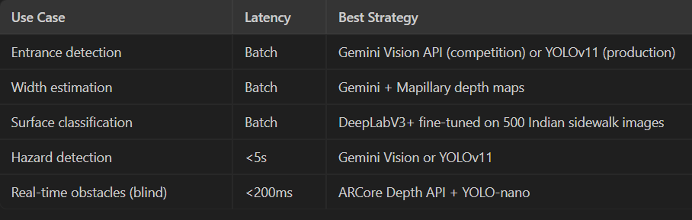
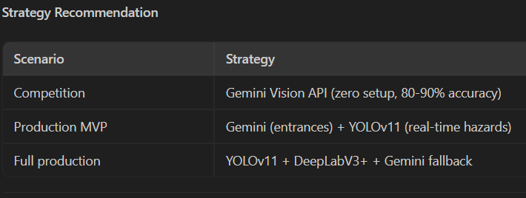

5.2 The Two-Tier Voice Architecture
To balance fast turn-by-turn alerts with natural conversational briefings, split the voice pipeline into two distinct tiers:
TIER 1: SAFETY-CRITICAL NAVIGATION (<50ms Latency / Zero Network Overhead)
Trigger: Geolocation Event (e.g., 15m to maneuver)
Pipeline: Hardcoded Maneuver Templates ──> Native Browser SpeechSynthesis API
Example: "Turn left in 10 meters. Step-free curb ramp ahead."

TIER 2: CONVERSATIONAL BRIEFINGS & SURVEYING (300-600ms Sub-Second Cloud Pipeline)
Trigger: User Voice Question or Post-Trip Feedback
Pipeline: Microphone Stream ──> Groq Whisper STT (150ms) ──> Groq Llama 3.3 / Gemini Flash (200ms) ──> ElevenLabs / Browser TTS
Example: "Is there a smoother route that avoids the Horniman Circle construction?"

Or

On-Device SLMs for Zero-Latency Offline Navigation
- In-Browser SLM via WebLLM or Transformers.js: Run an ultra-compact small language model (such as SmolLM2-360M, Phi-3.5-mini, or Gemma-2-2B) directly inside the browser using WebGPU.
- Offline Command Parsing: If mobile data drops in basements, underground transit hubs, or urban canyons, the local SLM can still parse spoken intents ("Find nearest elevator", "Repeat last step") and translate them into deterministic MapLibre camera actions or local graph lookups without making any cloud network requests.
Voice-to-Map Function Calling (Agentic Map Controls)
- Natural Language Map Manipulation: Pipe Tier 2 voice input (via Groq Whisper) into an LLM equipped with structured function calling to manipulate MapLibre directly.
- Dynamic Viewport Adjustments: Spoken phrases trigger concrete frontend methods—for example, "Show me the hill ahead" calls map.setPitch(60), while "Where are the ramps nearby?" toggles the GeoJSON barrier layer visibility and focuses the camera on the nearest verified point.

Semantic Query to Overpass QL Translation
- Dynamic Accessibility Filtering: Instead of hardcoding all OpenStreetMap tag combinations, use an LLM prompt pipeline to convert complex accessibility needs ("I need an illuminated route suitable for a motorized wheelchair with no curbs above 3cm") into an exact Overpass API query or custom OpenRouteService parameter payload on the fly.
Some info
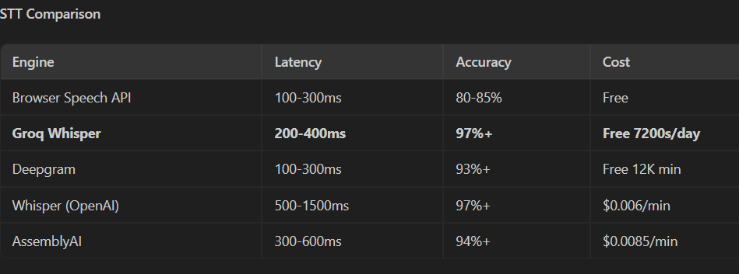

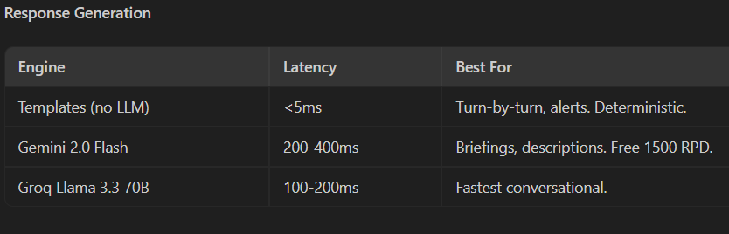
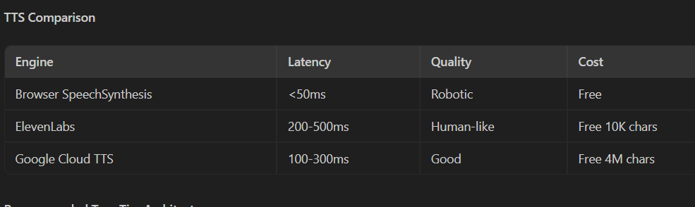
I think in below ways we can use diff voice architectures.
REAL-TIME (hazard, turn, surface): Template -> Browser SpeechSynthesis. <50ms. No network.
BRIEFINGS (preview, entrance): Gemini Flash -> ElevenLabs. 500-800ms. Quality over speed.
CONVERSATIONAL (surveyor, Q&A): Groq Whisper -> Groq Llama -> Browser TTS. 300-600ms.
OFFLINE: Template -> Browser SpeechSynthesis. All critical instructions work offline.

6. Spatial Frontend & 3D Mapping Architecture
6.1 MapLibre GL JS vs. CesiumJS
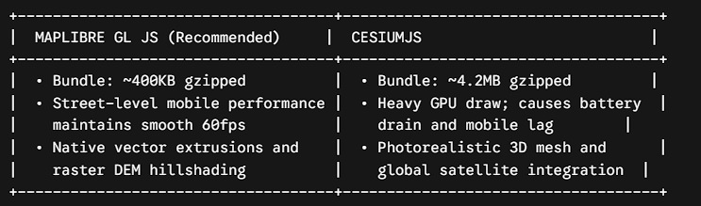

Architectural Verdict: Use MapLibre GL JS. CesiumJS is designed for planetary and aerospace visualizations; running it on mid-range smartphones while simultaneously processing camera, voice, and GPS loops leads to thermal throttling and battery drain. MapLibre provides native 3D building extrusions, pitched camera angles, and raster DEM hillshading with a fraction of the overhead.
But cesium acha dikta hai so vahi acha hai ig.
6.2 Spatial Geofencing & Orientation Engine
- DeviceOrientation API: Captures the device's physical magnetometer heading via the window deviceorientationabsolute event. The application computes the delta between the user's heading and the target way-point vector, powering the blind profile's clock-face relative audio instructions.
- Geofence State Machine: Implements a two-phase spatial boundary model:

[User Approaching Hazard] │ ----
[Phase 1: Enter 15m Radius] ──>
Suppress dialogs; mute notifications to prevent distraction │ ---
[Phase 2: Exit 15m Radius] ──>
If user paused/detoured: Trigger 1-Tap / Voice verification prompt ──>
If smooth traversal: Register implicit path clearance.

Inshort
DeviceOrientation (Compass)
Critical for blind: "Turn to 2 o'clock" needs heading. deviceorientationabsolute event gives alpha (0-360). Convert route bearing to clock-face relative to heading.
Geofencing
15m radius around hazards, 30m around entrances. State machine: onEnter (prepare, don't prompt yet), onExit (safe to verify). Wheelchair: only prompt on speed drop. Blind: audio warning before entering zone.
GPS Bounce Mitigation
- Kalman filter: 10m bounce -> 3-5m
- Snap-to-road: project onto route graph edge
- If snap distance >25m: uncertain
- Voice landmark: "Have you passed the pharmacy?"

7. The Four Ultimate Architectural Plans
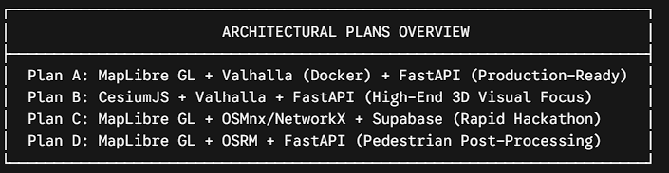

Plan A: MapLibre GL + Valhalla + FastAPI (Recommended Production Stack)
- Core Idea: Production-grade self-hosted routing. Valhalla provides real accessible routing with custom wheelchair/blind/deaf costing. FastAPI enriches maneuvers with OSM + elevation + hazard data. MapLibre renders premium 3D map.

- Tech Stack:
- Frontend: Next.js 16, React 19, TypeScript, MapLibre GL JS v5, GSAP/Framer Motion, Web Speech API, Tailwind v4
- Backend: FastAPI, SQLAlchemy 2.0 + GeoAlchemy2, httpx, Groq Whisper (STT), Gemini Flash (LLM)
- Infrastructure: Valhalla (Docker), PostgreSQL 15 + PostGIS 3.4, Redis, Open-Meteo Elevation, MapTiler, Mapillary
- Why Choose This: Valhalla processes route queries in under 50ms and dynamically alters edge penalties using exclude_locations without rebuilding the graph.

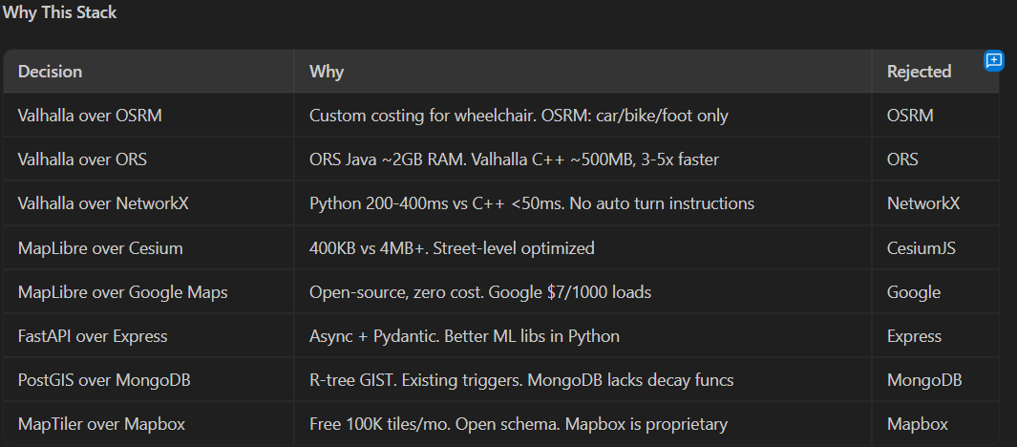

Plan B: CesiumJS + Valhalla + FastAPI (High-End 3D Visual Focus)
- Core Idea: Cinematic 3D globe-to-street. CesiumJS for true 3D terrain + Google Photorealistic buildings. Visually unmatched but heavier.
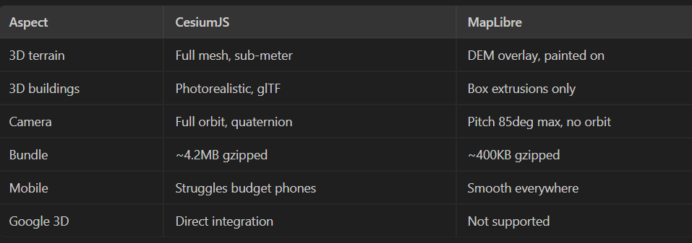
- Trade-Offs: Visually impressive for desktop presentations, but the 4.2MB client bundle can cause performance drops on budget mobile hardware.
- Lags on budget Android (disabled users often have budget devices)
- 4.2MB load on 4G is painful
- Overkill for 2km routes
- Dev time 1.5-2x of MapLibre
- But accha dikta hai so good option
Plan C: MapLibre GL + OSMnx/NetworkX + Supabase (Rapid Hackathon Stack)
- Core Idea: Eliminates Docker and C++ compilation entirely. Pre-downloads a target neighborhood (e.g., Mumbai BKC) as a .graphml file, running path calculations directly in Python using NetworkX.
- Trade-Offs: Graph operations take 200–400ms and cannot easily scale beyond a local bounding box, but this setup avoids external DevOps overhead.
- frontend: Next.js + MapLibre + @supabase/supabase-js + Framer Motion
- Backend: FastAPI + OSMnx + NetworkX + Supabase SDK + Open-Meteo Managed: Supabase (PostGIS+Auth+Storage), MapTiler, Open-Meteo, Mapillary
Plan D: MapLibre GL + OSRM + Supabase (Pedestrian Post-Processing)
- Core Idea: Queries a standard OSRM pedestrian API and passes the resulting path to FastAPI to inspect for stairs and hazards. If an obstacle is detected, the engine attempts to route around it using exclusion boxes.
- Trade-Offs: Post-processing cannot easily identify alternative accessible paths if the main road is blocked, making it less reliable for complex accessibility routing.

Architectural Comparison Matrix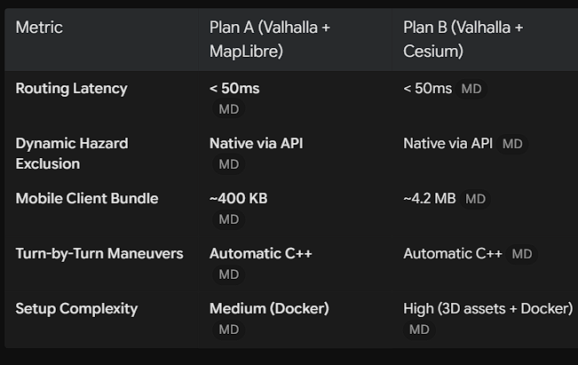

8. Detailed End-to-End User Journeys
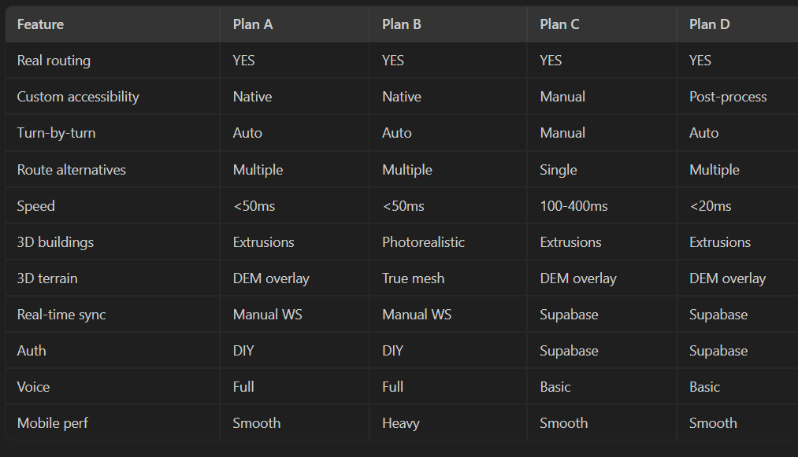

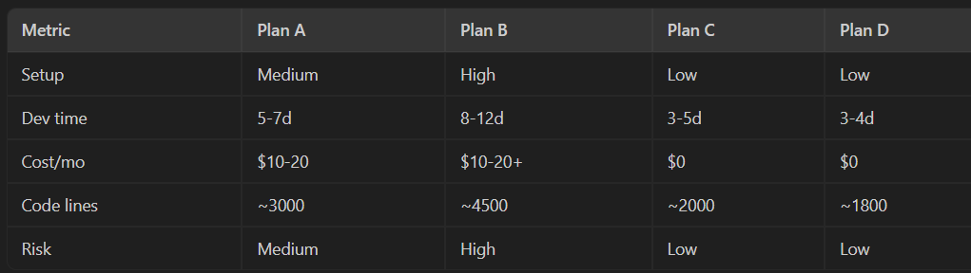
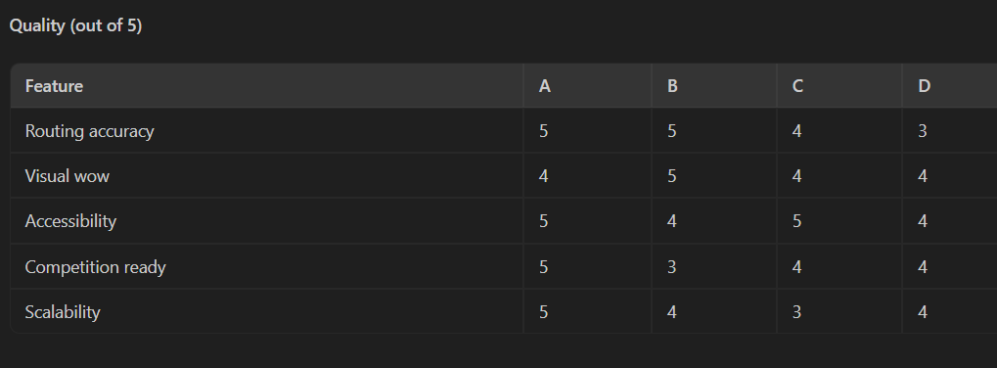
- Competition: Plan A. Best routing + visual + buildability balance.
- Time tight (2-3d): Plan C. Zero infra. Frontend identical to A.
- Max visual: Plan B. Only with 10+ days and good hardware.
- Avoid Plan D: OSRM lacks custom costing.

8.1 Wheelchair User Journey
- Launch & Audit: The app loads the user's saved profile (Motorized: Max Grade 5%, Step-Free Mandatory).
- Destination Search: The user inputs their destination. The camera shifts to a 45-degree angle, highlighting the route line color-coded by slope difficulty.
- Route Inspection: The UI displays the Accessibility Nutrition Label (Max Grade: 3.2% [PASS], Surface: 100% Paved [PASS]) alongside the Last 50 Feet Entrance Card showing the destination's push-button ramp.
- Active Navigation: As the user begins moving, the camera drops to a 60-degree street-level view. 15 meters prior to an upcoming hill, the audio engine announces: "Approaching 3.2% incline for 35 meters".
- Hazard Verification: When exiting a 15m radius around a recently reported sidewalk obstruction, the app checks if the user experienced significant delay; if so, it prompts: "Is the sidewalk still blocked? [YES] [NO]".
- Arrival: Within 15 meters of the destination, the app displays the verified doorway photo and highlights the step-free entrance ramp.

8.2 Blind / Visually Impaired Journey
- Voice Activation: The app opens in an audio-focused mode: "PathClear active. Where would you like to go?"
- Voice Search: The user speaks their destination. The system responds: "Route found: 650 meters, step-free, 85% covered by tactile paving. Two signalized pedestrian crossings. Would you like to start?"
- Active Guidance: The interface remains largely dark to conserve battery while delivering clock-face audio instructions: "In 10 paces, turn toward your 2 o'clock to align with the tactile ground paving."
- Hazard Alert: 20 meters before reaching an unpaved construction perimeter, the phone issues a distinct three-pulse vibration and provides an audio warning: "Caution: Scaffolding encroaching on right walkway in 15 paces. Veer slightly left."
- Arrival Handover: Upon arrival, the assistant guides the user to the door handle: "You have reached the entrance. The push-button door actuator is located on the right brick post at waist height."

8.3 Deaf / Hard-of-Hearing Journey
- Visual Configuration: The app opens with high-contrast text, clear directional iconography, and audio cues disabled.
- Route Preview: The user reviews the route using the Clearance Checklist, verifying that the path avoids unseparated vehicular spaces and poorly lit alleys.
- Active Guidance: The navigation HUD pins an oversized turn indicator and road type badge to the top of the viewport.
- Visual Caution Alerts: As the user nears an active commercial driveway or alleyway, the screen displays a blinking amber notification: "Caution: Active vehicular cross-traffic zone ahead."
- Arrival: The destination building highlights in teal, and the app displays a photo marking the location of the accessible entrance.

Or
user Flow: Wheelchair User
- OPEN: MapLibre 3D at GPS. Profile badge. Voice: "Where to?"
- SEARCH: Type/speak "Jio World Centre". Camera flies to destination.
- ROUTE PREVIEW: Valhalla route + enriched maneuvers. RFI: 0.23. Nutrition Label (Incline 3.2% PASS, Step-Free PASS). Last 50 Feet Card.
- REHEARSAL: Camera street-level fly-through at 10x speed.
- START NAV: Camera top-down -> 60deg pitch. Route glow appears. GPS tracking.
- ACTIVE: "Turn right in 50m. Uphill 3.2% for 30m. Cobblestone in 20m."
- HAZARD (15m geofence): "Construction reported. Still blocked? [Yes][No]"
- LAST 50 FEET: "Gate 3. Auto-sliding, 42in. Ramp left, 2.1%. Tactile present."
- ARRIVAL: Building glows teal. Trip summary + rating.

User Flow: Blind/Visually Impaired
- OPEN: "PathClear ready. Voice mode." -> "Say destination or help."
- SEARCH (voice): "1.2km, 15 min. Step-free. Tactile 80%. One unsignalized crossing."
- PRE-CHECK (voice): Tactile %, crossing signals, hazards listed.
- ACTIVE (haptic+audio): Clock-face directions. "Follow ribbed tiles 30 paces." "Turn to 2 o'clock." Haptics: turn=2 short, hazard=3 rapid.
- VERIFY (voice after exit): "Scaffolding passed. Still there?" -> "Noted."
- LAST 50 FEET (voice): "Push-button door at 2 o'clock, waist height, right side."

User Flow: Deaf/Hard of Hearing
- Full visual HUD, no audio. Large direction arrows.
- Haptics: turn=[dot dot], hazard=[dash dash dash].
- Amber banners for vehicle crossings. 56px verification buttons

Haptics ka meaning- Haptics refers to technology or science that uses touch, vibrations, and motions to communicate with a user

More detail user flow:
Phase 1: Voice-Guided Onboarding & Profile Creation
When a new user opens the PathClear web application, they are not greeted by a dense, inaccessible web form. Instead, the screen displays a clean, high-contrast welcome interface, and the conversational voice agent (powered by the sub-second Groq Whisper/LLM pipeline) immediately initiates a hands-free onboarding sequence.
- The Greeting: "Welcome to PathClear. To guarantee a safe route, I need to know how you move. Are you using a wheelchair, navigating with vision loss, or do you have a different mobility need?"
- Dynamic Constraint Gathering: Based on the user's initial answer, the agent asks tailored follow-ups. If the user says "wheelchair," the agent asks: "Are you using a manual chair or a motorized scooter, and what is your maximum comfortable incline?"
- Profile Lock-in: The backend saves this data into a persistent profile (e.g., wheelchair_motorized, max_grade=8%, step_free=true). The UI instantly adapts to this profile, shifting to a screen-reader-optimized layout, a high-contrast visual HUD, or a standard 3D map interface.
Phase 2: Destination Search & The Route Audit With the profile active, the map initializes. For visual profiles, MapLibre 3D centers on the user's GPS coordinates, displaying their profile badge and prompting, "Where to?".
- Search Initiation: The user types or speaks a destination, such as "Jio World Centre". The 3D camera instantly flies across the city to the destination.
- The Pre-Check (Profile-Specific):
  - Wheelchair Profile: The engine calculates the Valhalla route and displays the enriched maneuvers, the Route Friction Index (e.g., RFI: 0.23), the Accessibility Nutrition Label (showing Pass/Fail for inclines and steps), and the "Last 50 Feet" destination card.
  - Blind Profile: The voice agent takes over, providing an auditory summary: "1.2km, 15 minutes. Step-free. Tactile 80%. One unsignalized crossing." It lists the tactile percentages and active hazards explicitly.
  - Deaf Profile: A full visual HUD loads without audio, relying on heavy contrast and iconography.
Phase 3: The Pre-Trip Rehearsal (Anxiety Reduction) Before the GPS tracking begins, visual users (like wheelchair or scooter users) experience the Route Rehearsal. The MapLibre camera drops to street level and executes a 10x speed fly-through of the entire route. This cinematic preview allows the user to visually inspect the glowing route line, physically see the 3D building extrusions, and anticipate where the steep slopes or hazards are located before they ever leave their house.
Phase 4: Active Multi-Modal Navigation The user taps or says "Start Navigation." The camera shifts from top-down to a 60-degree pitched angle, the route glow activates, and GPS tracking begins. Guidance adapts radically based on the profile:
- Wheelchair / Motorized: The agent provides physical exertion foresight. "Turn right in 50m. Uphill 3.2% for 30m. Cobblestone in 20m."
- Blind / Visually Impaired: Visual maps are ignored. The agent uses clock-face directions and environmental anchors: "Follow ribbed tiles 30 paces" and "Turn to 2 o'clock." Haptic feedback reinforces this (e.g., 2 short vibrations for a turn, 3 rapid vibrations for a hazard).
- Deaf / Hard of Hearing: Large direction arrows dominate the screen. If crossing an active vehicle zone, amber banners flash to warn of cross-traffic. Turn cues are delivered via distinct [dot dot] haptics, while hazards trigger aggressive [dash dash dash] vibrations.
Phase 5: Geofenced Hazard Verification As the user traverses the route, they enter a 15-meter geofence around a community-reported hazard (e.g., construction).
- To prevent dangerous distractions, the app remains silent while the user navigates the physical obstacle.
- Upon exiting the geofence, the app triggers the verification loop. For visual users, a 56px oversized button prompt appears: "Construction reported. Still blocked? [Yes][No]". For blind users, the voice agent casually asks: "Scaffolding passed. Still there?" and confirms the user's spoken answer with "Noted."
Phase 6: The "Last 50 Feet" Arrival Handover
Standard navigation apps fail by routing to the center of a building. PathClear routes to the exact accessible door.
- As the user breaches the final 15 meters, the destination building visually glows teal.
- The "Last 50 Feet" system takes over. For a wheelchair user, it displays the entrance photo and reads the specs: "Gate 3. Auto-sliding, 42in. Ramp left, 2.1%. Tactile present."
- For a blind user, the agent guides them to the physical hardware: "Push-button door at 2 o'clock, waist height, right side."
Phase 7: Post-Trip Summary & Next Actions (The Continuous Loop) The journey concludes with a trip summary and a friction rating screen. To close the loop gracefully, the voice agent transitions from navigation to concierge.
- The Prompt: "You've arrived safely. What would you like to do next?"
- Contextual Options: The UI (and voice agent) offers three high-value follow-up actions:
  - "Should I save this specific entrance to your favorites for next time?" (Improves future routing speed).
  - "Would you like me to map the nearest verified accessible restroom inside this facility?" (Solves the immediate post-arrival biological need).
  - "Shall I schedule a notification for your return trip before sunset?" (Proactive safety, avoiding poorly lit or unsafe night travel).

Frontend Ideas:
Dynamic 3D Camera Angles:
- Search Mode: Top-down 2D view (Pitch: $0^\circ$, Zoom: 14).
- Route Review: Angled perspective (Pitch: $45^\circ$, Zoom: 15.5).
- Active Guidance: Tilted street-level tracking (Pitch: $60^\circ$, Bearing tied to GPS heading, Zoom: 17.5).
- Destination Arrival: Slow camera orbit around the destination building (Pitch: $45^\circ$, Zoom: 18.5
3D Building Highlights: Use MapLibre’s fill-extrusion layer to render surrounding architecture in neutral dark slate, while dynamically highlighting the destination building in glowing teal upon arrival

Particle Trail:30 tiny glowing particles flow along route line like a river of light.

Ek dark mode
Custom 3D glTF Models: Load lightweight 3D models (such as an automated wheelchair ramp, an elevator shaft, or an accessible doorway icon) directly onto the map canvas at key navigation waypoints.
Libraries
Framer Motion (32KB), GSAP (28KB), Lottie React (15KB), Recharts (~40KB), Radix UI (tree-shaken).

If using maplibre:
https://youtu.be/H_xJ0W58FVk?si=jjFsVhrCUYn1oCLa
summary of vid: This video, titled "MapLibre Tutorial 04: Display Buildings in 3D," provides a straightforward, step-by-step guide on how to render interactive 3D buildings using MapLibre and MapTiler[cite: 3].
Here is a summary of the key concepts covered:
* Prerequisites: To execute the code, you must first obtain a MapTiler API key and set it as an environment variable[cite: 3].
- Basic Implementation: The tutorial demonstrates that you can add 3D buildings to any location on the globe using a simplified function: map.add_3d_buildings()[cite: 3].Camera Controls: It explains how to manipulate the 3D view programmatically by setting the pitch (the up-and-down camera angle, typically between 0 and 60) and the bearing (the camera's rotation relative to North)[cite: 3].
Zoom Behavior: The video notes that 3D building data layers are tied to zoom levels[cite: 3]. If you zoom out too far (e.g., a zoom level smaller than 15), the buildings will disappear to maintain performance[cite: 3].
Data-Driven Styling: A major portion of the tutorial focuses on customizing building colors based on their physical height[cite: 3].
You can pass custom arrays for both values (height in meters) and colors (using standard color names or Hex codes)[cite: 3].
The presenter highlights why this is important: a color scale that works for New York City's massive skyscrapers will not look good in a smaller city like Knoxville, Tennessee, where most buildings are under 20 meters tall[cite: 3].
- Basemap Integration: Finally, the video shows how to add layer controls and overlay these 3D buildings on top of different basemaps, such as satellite imagery (m.add_basemap('Imagery')), to verify that the 3D footprints align properly with the real world
Crazy frontend idea:
standard map extrusions look like gray cardboard boxes. By combining CesiumJS with Google's Photorealistic 3D Tiles API, you instantly upgrade your map to look like Google Earth or a modern AAA video game.
simply inject your Google Cloud API key into the Cesium3DTileset object in your Next.js frontend, and Google streams the photorealistic mesh of the city directly to the browser

https://youtu.be/Yj11hdq2jgA?si=oY5qfKLFZxSzpryi.
Summary: Google's Immersive 3D Data for Developers: The video highlights that Google Maps Platform is making its photorealistic 3D map data, the same source powering Google Earth, available to developers through two new components. * Photorealistic 3D Tiles (Experimental Release): * Developers can access this comprehensive 3D map data via the Maps Tiles API, avoiding the high cost and time of creating custom real-world 3D models. * The 3D tiles provide a seamless mesh model textured with high-resolution imagery, available in over 2,500 cities across 49 countries[cite: 27]. * The data follows the 3D Tiles OGC standard, enabling compatibility with renderers like CesiumJS, deck.gl, three.js, or custom renderers, giving developers control over visual design and interactions[cite: 27]. * Google collaborated with Cesium to optimize rendering performance, and the API also seamlessly integrates data attributions. * This data is also available in AR Core tools like Unity Geospatial Creator and Adobe Aero for anchoring AR objects to the real world. * Aerial View API: * For developers needing quick, low-latency 3D visuals without managing their own renderer, Google introduced the Aerial View API* It allows users to generate cinematic, visually stunning 3D videos of locations in the US simply by submitting a postal address[* This provides a cost-effective alternative to drone capture, circumventing flight regulations and high expenses, while still providing rich contextual information about a location's surroundings.
https://youtu.be/TZxFovugAbU?si=B3NjS5zIfRvoW7w6

Real-Time Environmental Lighting (Mapbox Standard Style)
Mapbox v3 introduced dynamic 3D lighting that reacts to the sun's actual position.
- Time-Synced Shadows: Sync the map's lighting environment to the user's local device time. If they are navigating at 5:00 PM, the 3D buildings will cast long, realistic shadows across the route line.
- Safety Context via Lighting: This isn't just a visual trick; it adds real accessibility value. A visually impaired user can see exactly which parts of their route will be in deep shadow or glaring sunlight during their specific travel window.
Drop a glowing, cylindrical beam of light directly onto the verified accessible doorway coordinate, casting a glow onto the street. An immersive pop-up card simultaneously slides in from the side of the screen displaying the actual photo of the entrance.
!.
Another idea: Keep your primary application canvas locked in a highly pitched, immersive 3D street-level view for forward navigation. In the top right corner, overlay a floating, circular frosted-glass mini-map. Render a secondary 2D top-down view of the exact same location inside this circle. This gives users the cinematic appeal of 3D navigation while preserving the spatial orientation of a traditional 2D map.

Also try: admin Data Dashboard with Kepler.gl
For the backend or presentation portion of your hackathon, you can wrap deck.gl with Kepler.gl (another Uber open-source project). Kepler is a data-agnostic, high-performance web application built for visualizing large-scale geospatial data. You can drop your entire database of accessible doorways, user routes, and barriers into it to instantly generate a stunning, presentation-ready 3D dashboard without writing custom WebGL rendering logic.
In your ,Kepler.gl sits at the very top of the visualization stack, but it serves a completely different purpose than your mobile navigation interface.
Think of the hierarchy like this:
- WebGL: The core graphics engine in the browser.
- deck.gl: The framework that uses WebGL to draw 3D map data (what you use for your mobile routes).
- Kepler.gl: A complete, pre-built React application and UI dashboard built on top of deck.gl.

Kepler.gl is not meant for turn-by-turn mobile navigation frontend. It is too heavy and has a dense, analytical user interface.
Instead, Kepler.gl is your Admin Dashboard or City Planner View.
While individual users are navigating the streets using your clean MapLibre/deck.gl mobile UI, they are generating data (reporting broken sidewalks, verifying wheelchair ramps, generating route histories). You feed all of that aggregated backend data into Kepler.gl to view the macro-level health of the city.
To blow the judges away, create a secondary page in your Next.js app (e.g., /admin-dashboard).
Use MapLibre + deck.gl for the sleek, forward-facing mobile app that the user interacts with on the street. Use Kepler.gl on a desktop browser for the "Command Center" dashboard that visualizes all the accessibility barriers and safe routes across the entire city at once.

https://youtu.be/bPlKPvUu_XA?si=nWqCNRKOoV-LKe5a
summary: features of deck.gl can be used with the data that makes CesiumJS so powerful, but with a specific architectural caveat.
You generally do not run the deck.gl engine and the CesiumJS engine on the same screen at the same time. Running two massive WebGL globes simultaneously on top of each other will cause your browser to crash or lag terribly, especially on mobile.
Instead, deck.gl natively supports Cesium's 3D data formats.
Cesium created the industry standard for streaming 3D photorealistic cities, known as 3D Tiles. Deck.gl has a dedicated layer called the Tile3DLayer that is built specifically to ingest this format.
Here is how you combine the best of both worlds for your hackathon:
The "Best of Both Worlds" Setup
Instead of using CesiumJS as your map viewer, you use deck.gl as your master WebGL engine.
- The Base City: You use deck.gl's Tile3DLayer combined with @loaders.gl/3d-tiles to pull in Google Photorealistic 3D Tiles or data directly from Cesium ion. This gives you the stunning, photorealistic 3D globe aesthetic.
- The Overlay: On top of that 3D city mesh, you add your standard deck.gl GeoJsonLayer for styling your accessibility hazard points, or the TripsLayer to show the glowing, animated navigation route.
Why this is the ultimate hackathon architecture:
- One Rendering Engine: By having deck.gl handle both the 3D city and your custom route data, you maintain high 60fps performance because everything shares a single WebGL context.
- Unified Coordinate System: Deck.gl automatically handles the math of clamping your standard GeoJSON latitude/longitude route perfectly onto the complex terrain of the Cesium 3D Tiles.
- React Native Friendly: Because deck.gl is built specifically for React, you can manage the state of your 3D photorealistic map much easier than you could by trying to force CesiumJS into a Next.js component.

Layer 3 Problems
Data Bootstrapping and Integrity
The core operational challenge for PathClear is the "Cold Start" bootstrap problem, where a lack of data prevents user adoption, which in turn prevents crowdsourced data collection. To mitigate this, the system avoids relying solely on live users and instead executes batch seeding using Mapillary street imagery combined with YOLO computer vision models. The initial launch scope is heavily constrained to a 2km² focus area in BKC, augmented by partnerships with local NGOs and the direct importation of existing OSM accessibility tags.
Compounding this is the OpenStreetMap (OSM) data gap in India, where only approximately 15% of Mumbai sidewalks contain surface tags and roughly 5% possess tactile paving metadata. The architectural mitigation applies machine learning inference to fill blanks, organizes OSM India mapathons, and forces the routing engine to treat any untagged path as "unknown" with a baseline 0.5 confidence score.
To balance data quality against high-volume submission, the system recognizes that low-reputation users can corrupt the hazard confidence scores. To fix this, contributions are dynamically weighted by user reputation: bad reputation results in a low contribution to the confidence score, while a good reputation yields a higher contribution to the score. Furthermore, the API enforces a strict GPS proximity check requiring the user to be within 30 meters of a hazard to submit a report, while actively cross-validating statistical outliers.
Privacy, Liability, and Safety Risks
Routing vulnerable users into unverified, inaccessible paths creates a significant physical liability trap. To prevent physical harm, the application enforces Go/No-Go UI blocks for unknown terrain, defaults all unverified routing data to a <0.6 confidence score, explicitly displays these confidence levels to the user, and maintains a strict Terms of Service (TOS) indicating the tool is for informational purposes only.
Furthermore, continuous GPS tracking of disabled users exposes sensitive personal data that can be linked to medical therapy or housing status. Under strict regulatory frameworks like India's DPDP Act, mishandling this location data carries severe penalties. PathClear mitigates this privacy paradox through minimal data collection, transforming individual paths into anonymous heatmaps, and restricting GPS breadcrumb retention to less than 24 hours.
Hardware and Scope Optimization
Demo Day Risk: The system works perfectly in the BKC test zone but fails elsewhere. The mitigation involves seeding 3-5 routes across different neighborhoods to prove routing capability everywhere, honestly labeling coverage areas, and acknowledging that only the "Last 50 Feet" entrance feature is missing outside the core zones.
*Mast crazy idea*- Multi-Modal Gap: Users do not strictly walk; they frequently combine pedestrian transit with rickshaws and the Metro. The current mitigation is to explicitly display transit hubs alongside their elevator status, with future plans to integrate GTFS scheduling data and Valhalla for full multi-modal routing.
Battery Drain: Concurrent use of GPS, voice TTS, 3D mapping, and haptic vibrations causes rapid mobile battery depletion. Mitigations include caching GPS pings every 3 seconds, dimming 3D visuals when the phone is pocketed, utilizing template-based TTS, and offering a dedicated battery saver mode featuring 2D maps, reduced polling, and text-only guidance

